# ABC’s Inventory Management System

## Inception Phase Project Status Assessment

## Introduction

The Inception Phase Project Status Assessment document will cover the expectations, track the achievements and finally review and evaluate the project in the Inception Phase. Also, this Assessment shows that the team understands where the project stands in relation to its overall aims, and in regard to the objectives of the Inception phase.

## Expectations

## The primary goal of the Inception phase is to establish the case, prepare the plans for the viability of the proposed system through documents. When the Inception Phase finished, the team should:

## Be able to identify and apply appropriately the different steps in the UP methodology to produce software, as well as the main artefacts of the software development process, using project management tools to assist in timely completion of milestones.

## Be able to analyse and document application requirements using Unified Modelling Language (UML) modelling techniques and tools.

## Be able to evaluate and determine suitable technologies to be used in the project.

## Be able to verify design through delivery of a functional prototype.

## Be able to evaluate software unit and application quality through testing.

## Gantt Chart

The following illustration shows the inception phase progress during each iteration:

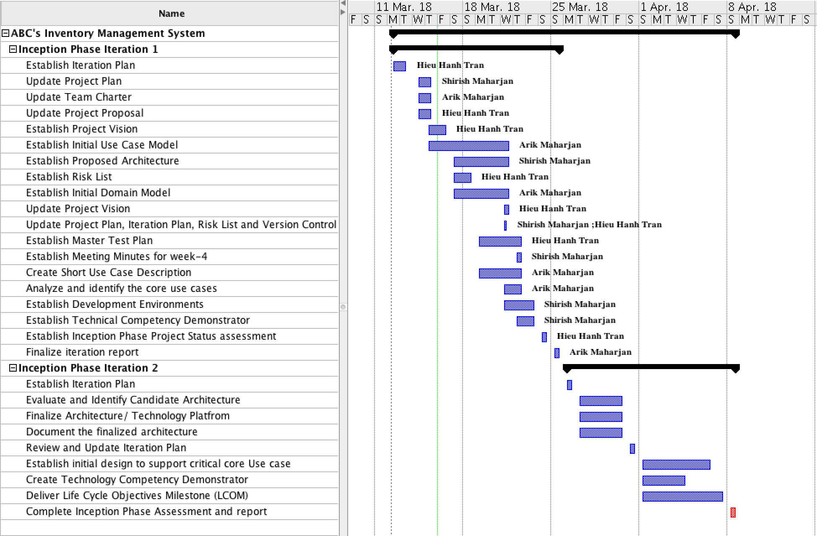

## Task Description

|  |  |  |
| --- | --- | --- |
| **Task** | **Description** | **Status** |
| **Inception Phase Iteration 1** |  |  |
| Update Project Proposal | The following updates were made:   * Provide the basic information about the project such as, project name, project member, project summary, etc. * Provide the Short Project Description to help the clients as well as team members have the overview of the project. * List the main components of architecture which are used to deploy the project. * Provide the team’s skill list about which skill will be used to deploy the project * Provide the potential issues list which the team might meet when doing the project. * Change the Project Name and Group Size from “Ware house Management System” to “ABC’s Inventory Management System” to make the name for specific. * Change the Architecture Outline to make it more accurate. * Re-define the Short Project Description in Project Proposal to make the project clearer and follow the missions as well as goals. * Fix the Short Project Description part in Project Proposal to be more specific such as:   + Show the current situation problems of the project.   + Explain how to solve those problems.   + Which methodology will be applied to solve those problems .   + What are the features of the system.   + What are the functionalities of the system. * Change the Template of the Project Proposal to be consistent with other files. | Completed |
| Update Project Plan | The following updates were made:   * Initial Plan document of the project * Referenced milestones from subject outline and assignments. * Add more tasks the Iteration I-1 in Project Milestones and Objectives part such as Risk List, master Test Plan, etc. * Add more information about the features of the System. * The Project Plan should not use the words such as “Head of” because those words only used for an organisation or department. * Deployment section should be improved the testing phase. (the project should be tested and get the feedback from other teams or stakeholders). * Add more role for each team member instead of 1 member only assign 1 role. * Project Practices and Measurements should be fixed by giving the shorter description but need to be reference to the Project Proposal. * Add Gantt Chart for the Project Practices and Measurements. | Completed |
| Update Iteration Plan | The following updates were made::   * Provide the Key milestones such as milestone and date of each milestone. * Prove the high-level objectives of the Iteration 1. * Provide the Work Item assignments to give the details of the task such as who will assign for the task, priority of the task, etc. * Provide the issues when doing the Iteration. * Provide the evaluation criteria for the Iteration 1. * Provide the assessments which is used for capturing and communicating results and actions from assessments. * Adjust date of Iteration 1 start from 14/03/2018 instead of 12/03/2018. * Complete the Assigned name for the tasks in work item assignments. * Add the Estimate Hours Work for each task in Work Item assignments. * Complete the Issues part and Assessment part. | Completed |
| Update Team Charter | The following updates were made::   * Change the team name. * Re-define the Mission and Objectives or Goals in Team Charter as well as limit the scopes. * Take the Team Communications part out of Team Charter to become a separate file. * Add some communication rules and expectations into the Team Charter such as time for meetings, medium of meetings, location for meetings. * Informing team members that the roles and responsibility will be rotated every month. * Add a brief description about the rotation of roles in Team Member Skill Inventory. * In the conflict resolution should mention that the project manager would be in-charge when having the conflicts between team members. * Add more role for each team member instead of 1 member only assign 1 role. | Completed |
| Establish Project Vision | The following details were included::   * Provide a brief introduction to the context of the project. * Provide a statement summarizing the problem being solved by this project. * Provide overall statement summarizing, at the highest level, the unique position the product intends to fill in the marketplace. * List all the stakeholders involve to the project. * Provide the detail of working environment of the target user. * Provide needs/ features and other product requirements. | Completed |
| Start work on the initial Use Case Model | Discuss among the team members and get the rough version of Use Case Model. | Completed |
| Establish Risk List | The following details were included::   * Provide the Risk Impact which is populated with the potential impact of the risk if it did become a project issue. * Provide Probability of Occurrence which is populated with the estimated probability that the risk will at some point become a project issue. * Provide Risk Map which is a calculated field based on the values selected for both Risk Impact and Probability of Occurrence. * Provide Risk Description which is populated with a description of the risk. * Provide Project Impact which is populated with a description of the potential project impact as a result of the risk. * Provide Risk Area which is populated with the symptoms of risk that may eventually lead to execution of a risk contingency plan. * Provide Trigger which is populated with the triggers that would indicate the requirement to execute contingency plan. * Provide Risk Response Strategy which is populated with the preferred risk response strategy. * Provide Response Strategy which is populated an appropriate response strategy to prevent the risk from becoming an issue. * Provide Contingency Plan which is populated with a description of the risk contingency plan. | Completed |
| Start work on the initial Domain Model | Discuss among the team members and get the rough version of Domain Model. | Completed |
| Establish Proposed Architecture | The purpose of this document is to describe the architecture philosophy, decisions, constraints, justifications, significant elements, and other overarching aspects of ABC’s Inventory Management System that shape the design and implementation of the system. This document will firstly describe the goals and philosophy of the architecture. This will be followed by any assumptions and dependencies effecting the architectural decisions. The document will then describe the architecturally significant requirements, decisions, constraints and justifications made. Different architectural mechanisms driving the design and implementation will also be described in this document. Finally, the document will present the key abstractions, architectural framework and architectural views of the system. | Completed |
| Update Project Plan, Iteration Plan, Risk List and Version Control | Update the Project Plan, Iteration Plan, Risk List and Version Control follow the feedbacks from Sponsor Meeting Minutes and Group Meeting Minutes documents. | Completed |
| Update Project Vision | The following updates were made::   * Give more details in Project Statement such as the problems, affects, impacts, etc. * Give more details about key benefits of Product Position Statement. * Add more stakeholders to the project such as designer, system analyst, etc. * Fix the User Environment part to be more detail and accurate such as the system will be run on Windows, etc. * The Needs and Features have been fixed depends on the system’s functionalities. * The Other Product Requirements have been added more non-functional functionalities. | Completed |
| Establish Meeting Minutes for week-4 | Discuss and assign the work for team members in week 4. | Completed |
| Establish NFR specification | This document specifies the requirements of the system. This document will describe the functional requirement of the system followed by the non-functional requirement. Moreover, the system will describe the expectations of the system interface including the user interface and the interfaces to external systems or devices. The system will also describe the business rules for the project. Finally, the document will describe the system constraint and compliance respectively. | Completed |
| Establish Master Test Plan | This document is used to define the details of the master test plan. Once the test plan is outlined, the document must be reviewed and approved by the lead technical representative on the project as well as the lead business representative on the project. If anything related to the test plan changes during the execution and testing phase of the project, this document should be updated and re-approved by both parties. | Completed |
| Create short use case description | Discuss among the team to establish a short use case description of all use cases of the system. | Completed |
| Analyse and identify the core use cases | Discuss among the team to analyze and identify the core use cases of the system. | Completed |
| Establish Development Environments | This document specifies the lists of system software/ applications used for running the ABC’s Inventory Management System. | Completed |
| Establish Technical Competency Demonstrator | This document specifies the techniques which are used to make the ABC’s Inventory Management System. | Completed |
| Establish Inception Phase Project Status Assessment | The Inception Phase Project Status Assessment document will cover the expectations, track the achievements, review and evaluate the project in the Inception Phase. | Completed |
| Finalize Iteration reports | Review, check and finalize all the documents which were made in Iteration 1 of Inception Phase. | Completed |

## Result

## The Project will establish an Inventory Management System for ABC company. In the first stage of Inception Phase, the team have identified the goal achievements, how to achieve those goals, understand the challenges what the team would face, have plans to cope with any contingencies, have the technical competence to achieve those goals by proposing these deliverables:

## Final Project Proposal Document

* + Project Plan Document
  + Iteration 1 Plan Document
  + Final Team Charter Document
  + Project Vision Document
  + Risk List Document
  + Proposed Architecture Document
  + Version Control Document for Iteration 1
  + NFR Specification document
  + Master Test Plan Document
  + Short Use Case Description Document
  + Inception Phase Competency Demonstrator Document